

**ONLINE SHOP**

**Software Requirement Specification**

– Hanoi, May 2022 –

**Table of Contents**

I. Overview 3

1. Introduction 3

2. System Functions 4

3. Common Requirements 5

II. Functional Requirements 6

1. <<Feature Name 1>> 6

a. <<Function Name 1>> 6

b. <<Function Name 2>> 6

2. <<Feature Name 2>> 6

# I. Overview

## 1. Introduction

Nowadays, people are busier and have less time to go shopping. That is why, online shopping is gradually taking the throne. Building a sales website is an economical and effective way for stores to introduce products and sales to increase sales for the store. With a sales website, they bring a lot of benefits not only to the buyer and also to the seller

Especially during the Covid-19 pandemic, customers and sellers can still buy and sell products without contacting each other. That provides safety during the covid pandemic for buyers and sellers while maintaining sales for the store.

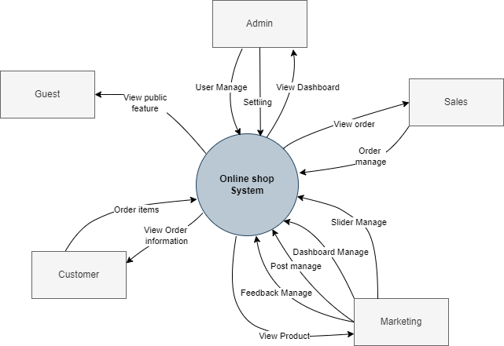

## 2. System Functions

#### a. Screen Flow

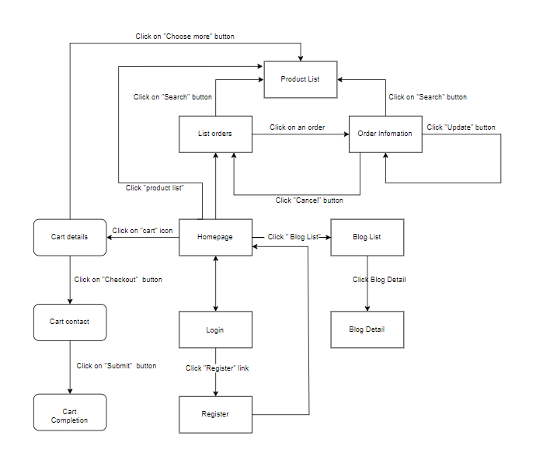

#### 

Figure 2-1: Screen Flow for User

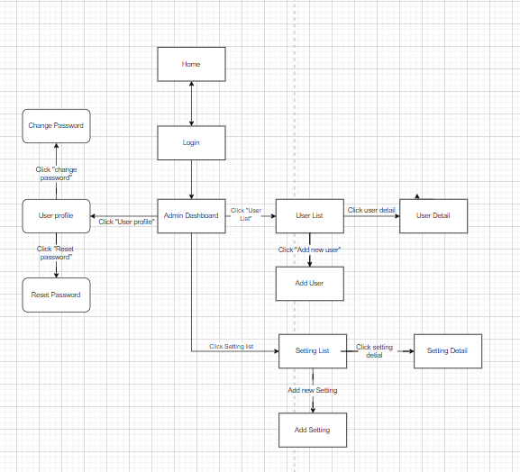

Figure 2-2: Screen Flow for Admin

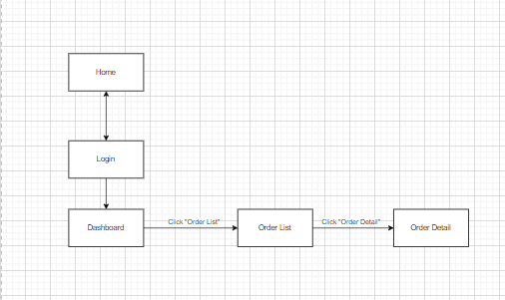

Figure 2-3: Screen Flow for Sale

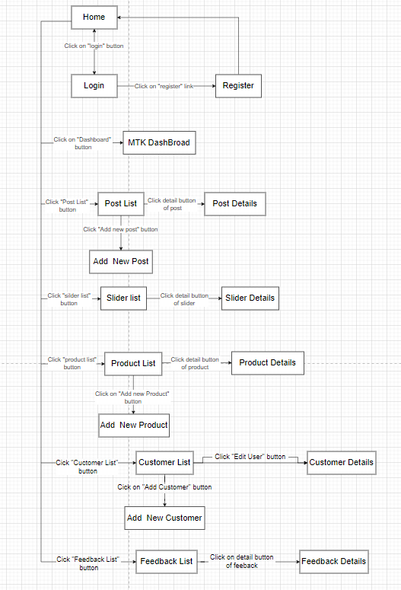

Figure 2-4: Screen Flow for Marketing

#### b. Screen Details

| **#** | **Feature** | **Screen** | **Description** |
| --- | --- | --- | --- |
| 1 | Public | Home Page | The starting page of the system. |
| 2 | Public | Blog List | List of blogs on the page. |
| 3 | Public | Blog Details | Show details of blog. |
| 4 | Public | Products List | Show the paginated list of products. |
| 5 | Public | Product Details | Show the information of product |
| 6 | Public | Cart Details | Show the cart details with list of the user's chosen products, the user can delete/remove product, choose more product, check out. |
| 7 | Public | Cart Contact | Show the list of user chosen product |
| 8 | Public | Cart Completion | Show the cart completion notes |
| 9 | Public | Feedback | Show feedback on products customers have purchased. |
| 10 | Common | User Login | Log in to the system. |
| 11 | Common | User Register | Is a pop-up screen that allows users to self-register into the system. |
| 12 | Common | Reset Password | Reset the password for the account. |
| 13 | Common | Change Password | Change the password for the account. |
| 14 | Common | User Profile | Allows the user to edit his/her profile information |
| 16 | Customer | My Orders | Show the list of users orders paginated |
| 17 | Customer | Order Information | Show the order details. |
| 18 | Marketing | MKT Dashboard | Show statistics of posts, products, customers, feedbacks & the trend of new customers. |
| 19 | Marketing | Posts List | Show list of posts |
| 20 | Marketing | Post Details | Show details of selected post |
| 21 | Marketing | Sliders List | Show list of current sliders on the website |
| 22 | Marketing | Slider Details | Show details of selected slider |
| 23 | Marketing | Products List | Show detailed post information |
| 24 | Marketing | Product Details | Show detailed product information |
| 25 | Marketing | Customers List | Show the list of customers |
| 26 | Marketing | Customer Details | Show detailed customer/contact information and allow users to view / edit them. |
| 27 | Marketing | Feedbacks List | Show the list of feedbacks paginatedly . |
| 28 | Marketing | Feedback Details | Show the list of feedbacks paginatedly, from that allow the user to change its status. |
| 29 | Sale | Sale Dashboard | Show the trend of success/total orders, and the revenues trends by day for the last 7 days. |
| 30 | Sale | Orders List | Show the list of orders paginatedly. |
| 31 | Sale | Order Details | Show the order details. |
| 32 | Admin | Admin Dashboard | Show statistics of new orders, revenues, customers, feedbacks, trend order counts. |
| 33 | Admin | Users List | Show the paginated list of registered users. |
| 34 | Admin | User Details | Show detailed user information . |
| 35 | Admin | Settings List | Show the paginated list of settings. |
| 36 | Admin | Setting Details | Show detailed user information. |

#### c. User Authorization

| **Screen** | **Admin** | **Sale** | **Marketing** | **Customer** |
| --- | --- | --- | --- | --- |
| Home Page | X | X | X | X |
| Blogs List | X | X | X | X |
| Blog Details | X | X | X | X |
| Product List | X | X | X | X |
| Product Details | X | X | X | X |
| Cart Details | X | X | X | X |
| Cart Contact | X | X | X | X |
| Cart Completion | X | X | X | X |
| Feedback | X | X | X | X |
| User Login | X | X | X | X |
| User Register | X | X | X | X |
| Reset Password | X | X | X | X |
| Change Password | X | X | X | X |
| User Profile | X | X | X | X |
| My Orders |  |  |  | X |
| Order Information |  |  |  | X |
| MKT Dashboard |  |  | X |  |
| Posts List |  |  | X |  |
| Posts Details |  |  | X |  |
| Sliders List |  |  | X |  |
| Slider Details |  |  | X |  |
| Products List |  |  | X |  |
| Product Details |  |  | X |  |
| Customers List |  |  | X |  |
| Customer Details |  |  | X |  |
| Feedbacks List |  |  | X |  |
| Feedback Details |  |  | X |  |
| Sale Dashboard |  | X |  |  |
| Orders List |  | X |  |  |
| Order Details |  | X |  |  |
| Admin Dashboard | X |  |  |  |
| Users List | X |  |  |  |
| User Details | X |  |  |  |
| Settings List | X |  |  |  |
| Setting Details | X |  |  |  |

In which:

* Admin: The organization leader/ manager, acts as the system adminstrator.
* Sale: The sales member of the organization.
* Marketing: The marketing member of the organization.
* Customer: They are registered users who are actual customers or potential customers.

#### d. Non-Screen Functions

| **#** | **Feature** | **System Function** | **Description** |
| --- | --- | --- | --- |
| 1 | Security | User Authorization | Specify the role of logged-in user and preventing unauthorized access via enter the links directly |

## 3. Common Requirements

| **#** | **Screen/ Function** | **Description** |
| --- | --- | --- |
| 1 | User Login | This is a pop-up screen which allows the user to enter email & password to login; on this page, there are also options for user to register new information or reset the password for the case user forget it. |
| 2 | User Register | This is a pop-up screen which allows the user to register to the system by enter following information: full name, gender, email, mobile; User then need to verify by clicking the link sent via email to him/her before being able to access the system |
| 3 | Reset Password | The user input his/her email to receive the reset password link. This link is sent to the user's email for his/her password resetting.  - On clicking the link, the user is redirected to the password resetting page in which s/he input new password (twice) for the system access |
| 4 | User Authorization | Implementation of authorization mechanism in the system, including the specify the role of logged-in user, his/her authorized page links (building the displayed menu items (in the front end) and preventing unauthorized access via enter the links directly) |
| 5 | User Profile | This is a pop-up screen which allows the user to edit his/her profile information, including the registered ones & the avatar image. |
| 6 | Change Password | This is a pop-up screen which allows the user to change his/her password by inputting his current password as well as new password. |
| 7 | Home Page | Show sliders, hot posts, featured products + the sidebar with the latest posts, static contacts/links  - Shown slider information includes its image and title; the user is redirected to the slider's backlink on his/her clicking  - Shown post information includes its thumbnail, title, brief-info; the user is redirected to the post's details on his/her clicking  - Shown product information includes its thumbnail, title, brief information; the user is redirected to the product's details on his/her clicking |

# II. Functional Requirements

## 1. Public Feature

### a. Home page

● Function trigger: This is the system start page upon entry.

● Function description:

o Role: User

o Purpose:show slides, hot posts, lates products

● Screen layout:

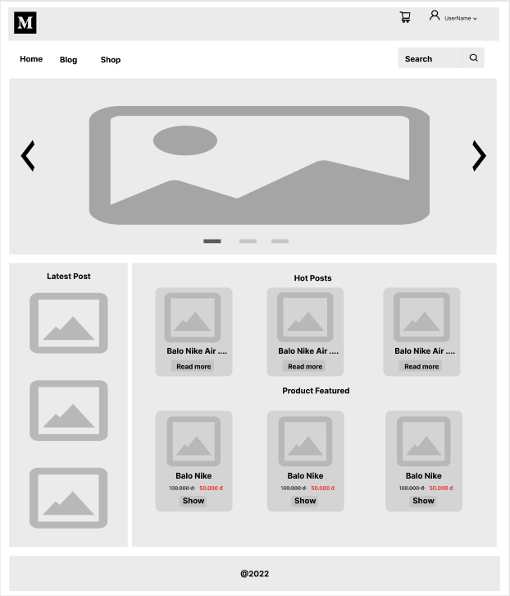

* Function Details: User can view product details on home page, click on product to add to cart, click on item on header to go to login page, cart page… Enter shop page, blog page by clicking link in title, product search.

### b. Blog list

● Function trigger: Blog screen can access from home page by clicking on Blog link.

● Function description: this is a display of sliders, search box, hot posts, latest products, sale products, product images. Links to login screen, store screen, blog screen.

● Screen layout:

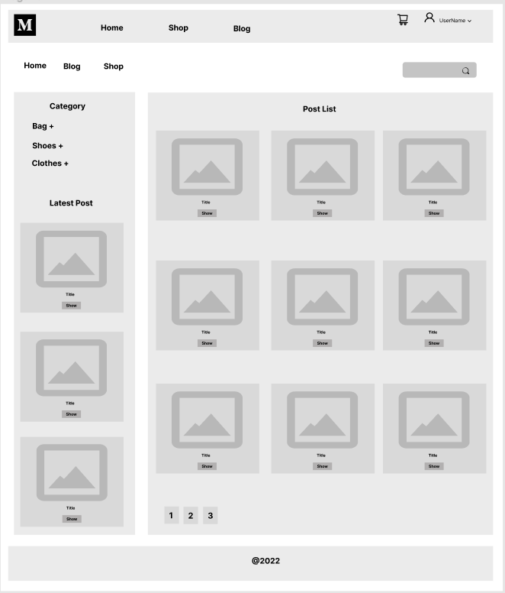

* Function Details: Show the posts paginatedly, shown post information includes its thumbnail, title, brief-info; the user is redirected to the post's details on his/her clicking

### c. Blog details

● Function trigger: Blog details can be accessed when the user clicks on the blog in the blog list.

● Function description: this is a display of sliders, search box, hot posts, latest products, sale products, product images. Links to login screen, store screen, blog screen.

● Screen layout:

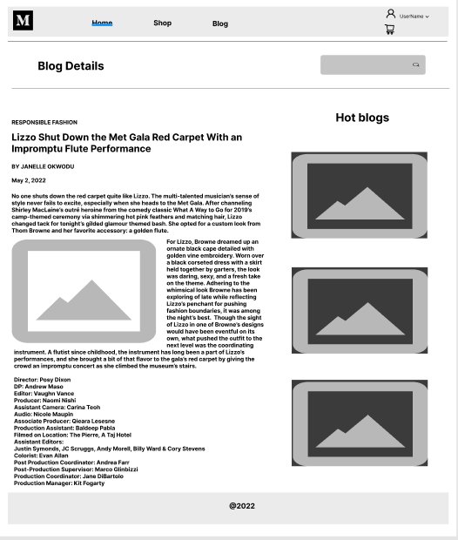

* Function Details: Show post details and sider with post search box, post categories and hot posts.

### d. Cart details

● Function trigger: The user can access the Cart Details page by clicking on the cart icon from the User page.

● Function description: The Cart Details page displays a list of products selected by the user to purchase.

● Screen layout:

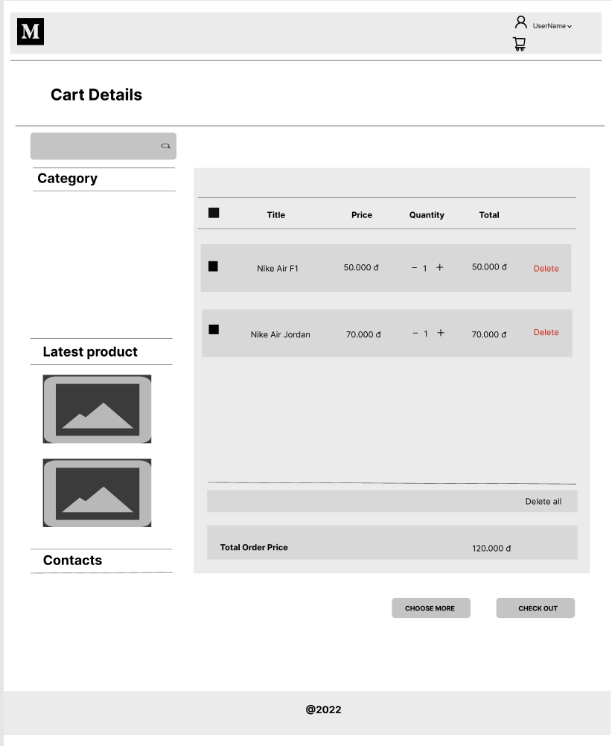

* Function Details: display cart details with list of user selected products and total order price. Users can change the quantity of each product, choose to delete the product by clicking on the delete icon. Click the Select Add Product button to go to the Product List page. Click the Checkout button to go to the Contact Cart page.

### e. Cart Contact

● Function trigger: User clicks Checkout button from Cart Details page to get access to Cart Contact page.

● Function description: Cart Contact page shows the list of user chosen products.

● Screen layout:

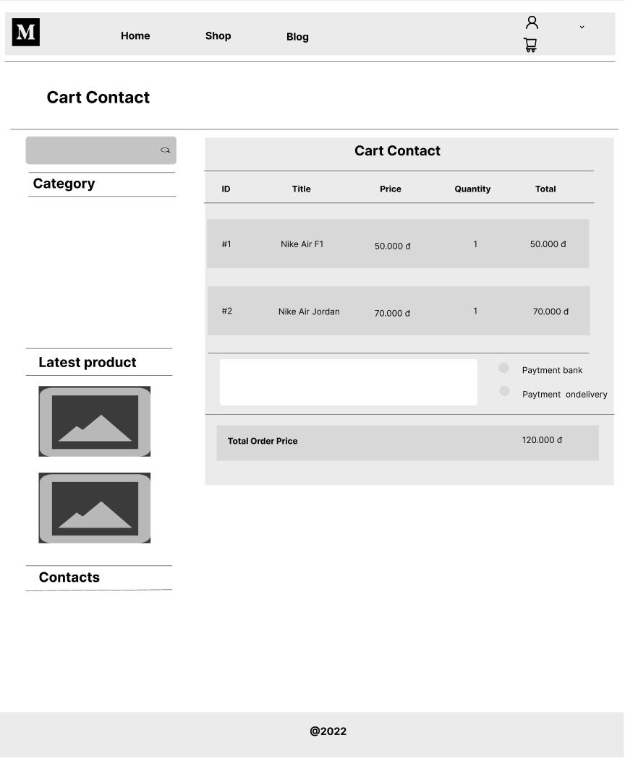

* Function Details: Displays a list of products the user has selected, the total order price, and recipient information for the user to edit or enter. User can click Change button to return to Cart Details page to change selected products, click Submit button to submit order.

### f. Cart Completion

● Function trigger: This page displays a message congratulating the successful order, the amount to be paid by the user, and payment instructions.

● Function description: The Cart Completion page displays when a user successfully places an order with order information, congratulatory message, total amount....

● Screen layout:

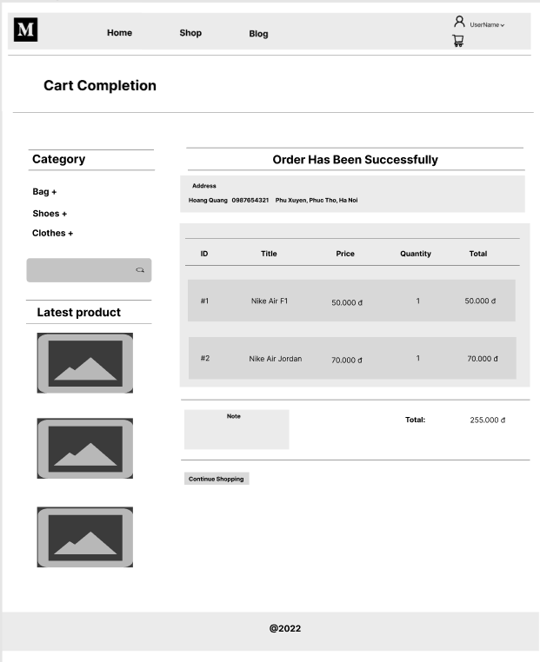

* Function Details: This page displays a cart completion message including the amount to be paid by the user and payment instructions, sider with product search box, product category and featured product.

### g. Feedback

Function trigger: Upon successful receipt of the purchased product, the recipient will receive a confirmation email with instructions for feedback on each product.

● Function description: Informative feedback including user information, star ratings, attached pictures and detailed comments.

● Screen layout:

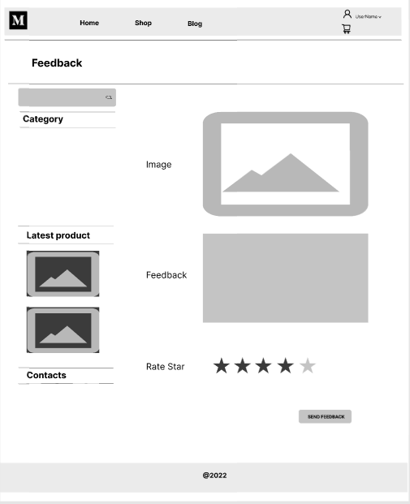

* Function Details: The page sider is also shown with the product search box, product categories, & five featured products (thumbnail, title). Users will add their feedback about the product.

## 

### h. Product List

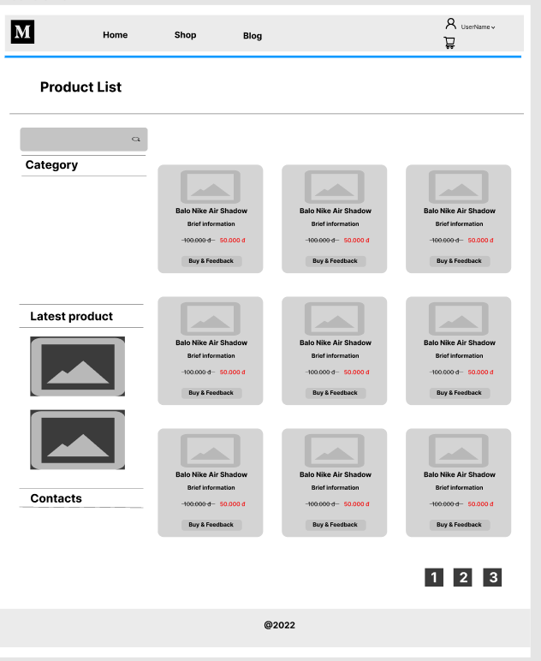

### i. Product Detail

* Function trigger: User click a product in the”product list” page, user user will be redirected to product detail page
* Function description:
  + Role : All role
  + Purpose: View product detail
  + Screen layout:

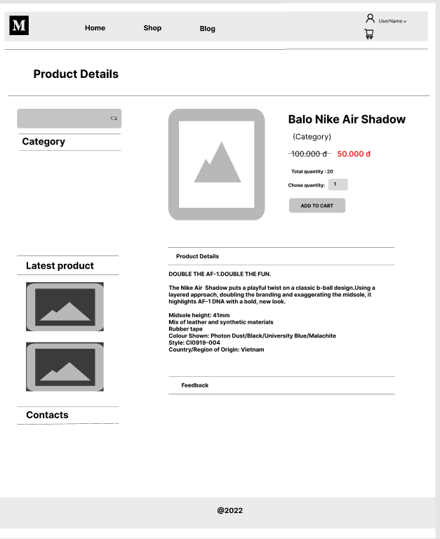

* Function detail:
  + User can view product detail
  + User can view all feedback of this product
  + User can add product to cart

## 

## 2. Common Feature

### a. User Login

● Function trigger: The user logs into the system when pressing the login button from the homepage.

● Function description: Users use their accounts to log in.

● Screen layout:

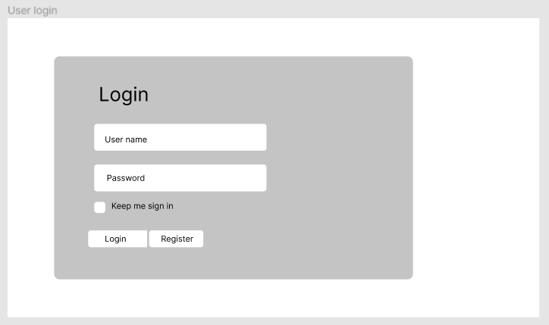

* Function Details: The login screen appears with the account information input boxes, the user will enter the email and password to log in.

### 

### 

### 

### 

### 

### 

### 

### 

### 

### 

### 

### b. User Register

● Function trigger: Users access this screen from the home page.

● Function description: Users use their accounts to log in.

● Screen layout:

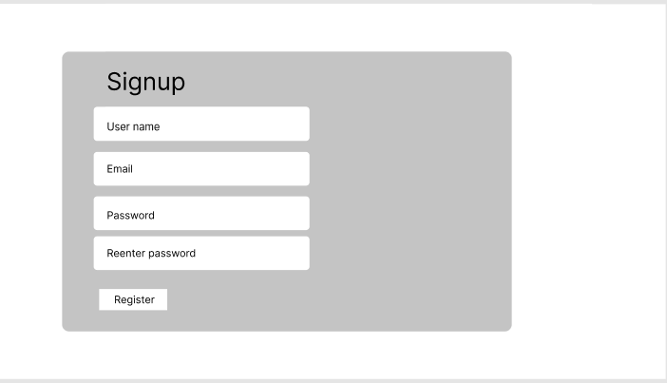

* Function Details: The registration screen will appear, users enter account information and enter user information such as full name, email, address ...

### 

### 

### 

### 

### c. Reset Password

● Function trigger: After user login into system, user click “Reset password” in the side bar.

User redirect to the reset password page

● Function description:

o Role: All user

o Purpose: User can reset their password

● Screen layout:

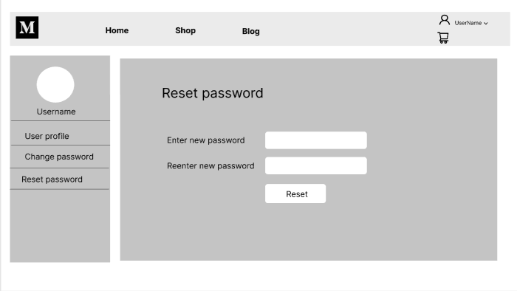

* Function Details: The registration screen will appear, users enter account information and enter user information such as full name, email, address ...

### d. Change Password

● Function trigger: The user selects Change Password in the upper right on the menu bar. The user will be redirected to the Change Password Page.

● Function description: Users change their password.

● Screen layout:

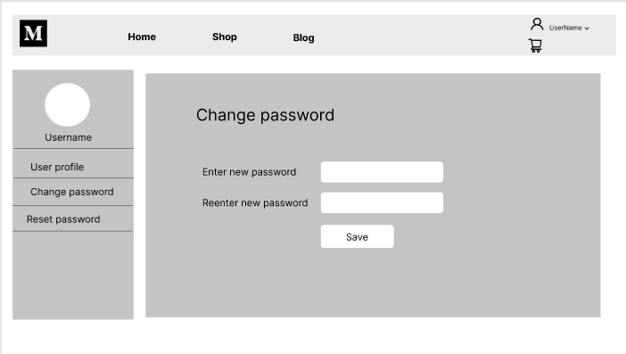

* Function Details: When the user selects Change Password on the menu bar, they are taken to a screen to change their password by entering their current password as well as their new password (twice).

### 

### 

### 

### 

### e. User Profile

● Function trigger: The user selects Change Password in the upper right on the menu bar. The user will be redirected to the Change Password Page.

● Function description: Users change their password.

● Screen layout:

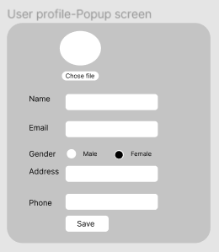

* Function Details: When the user selects Change Password on the menu bar, they are taken to a screen to change their password by entering their current password as well as their new password (twice).

### f. User Authorization

## 

## 

## 

## 

## 

## 

## 3. Customer Feature

### a. My Orders

● Function trigger: On the website after successful login, the user selects My Orders on the menu to view the orders.

● Function description: After accessing the page, the user will see a list of information about his order, can filter his order by order date. On the right side, there is a post search box with all featured post categories and products.

● Screen layout:

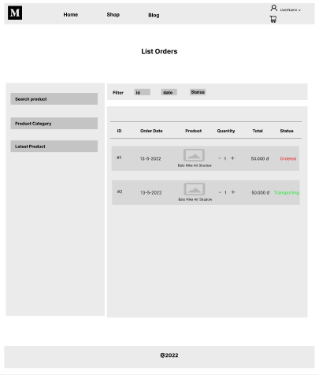

* Function Details: Pressing All Status combo box , a list of all order Status will be displayed on the screen. Pressing the Filter button, the list of Orders will be filtered accordingly. Pressing View button , user will be redirected to Order Information page. The Cancel button, order status will be changed to Cancelled. Users can search post by post name in the search box .

### b. Order Information

● Function trigger: The user selects My Orders in the upper right of the menu bar. User will be redirected to my orders page and click View Order Info.

● Function description: After accessing the Order Information page, the user will see a list of information about his order through thumbnail image, name, unit price, quantity... Feedback button allows user to give feedback about products, it is possible to cancel the submitted order.

● Screen layout:

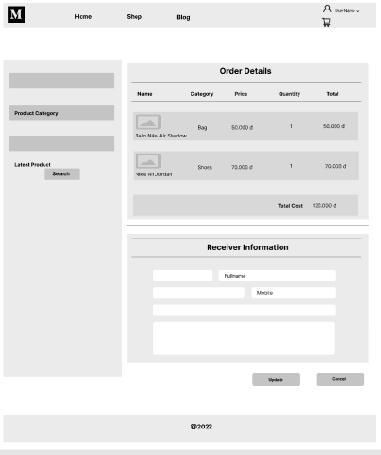

* Function Details: After selecting View from the order list, you will be redirected to the Order Information page. The page will show all order information
* Press the Cancel button, the order status will change to Canceled.

## 

## 

## 

## 

## 

## 

## 

## 4. Marketing Feature

### a. MKT Dashboard

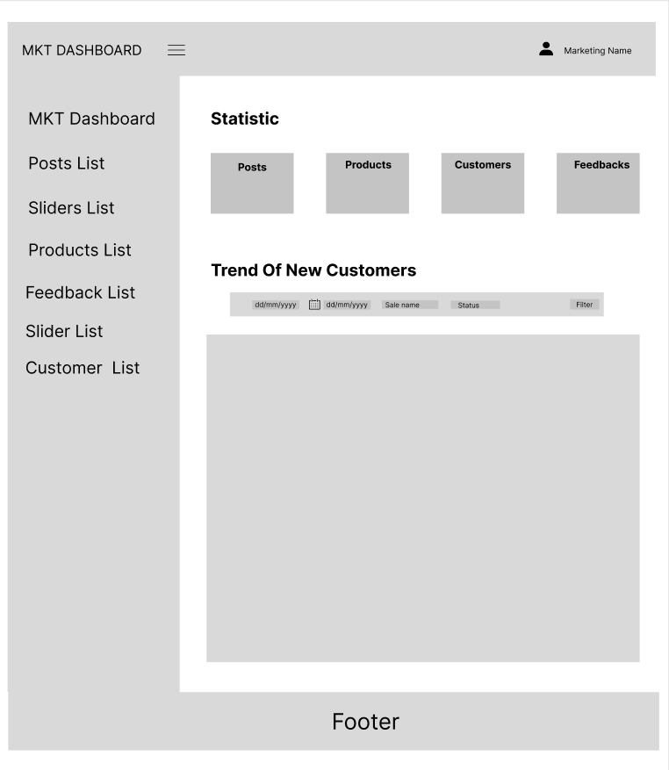

### b. Posts List

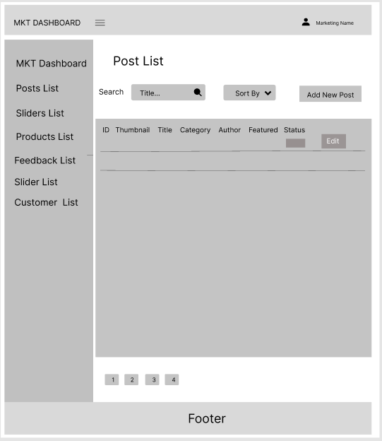

### c. Post Details

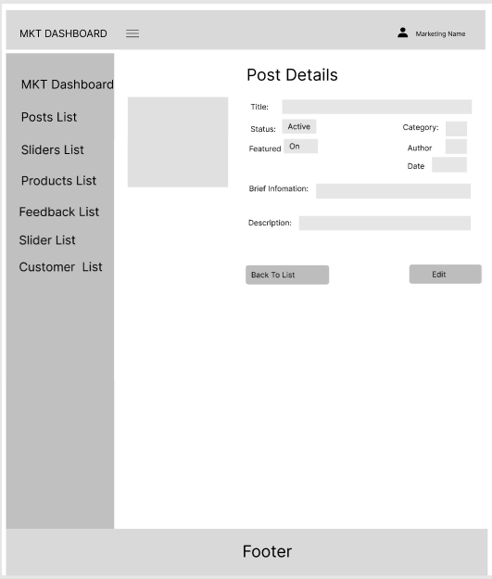

### d. Sliders List

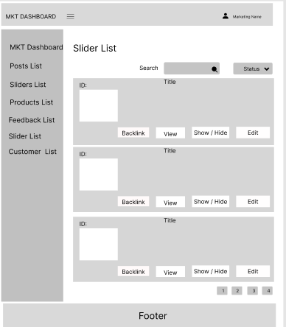

### e. Slider Details

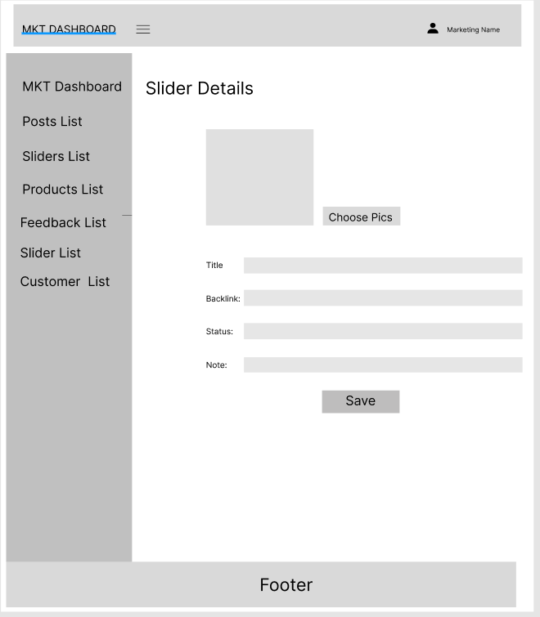

### f. Products List

* Function trigger: After logged website with role marketing, user click “Product List” in the sidebar, user user will be redirected to product list page
* Function description:
  + Role : Marketing
  + Purpose: View list priduct
* Screen layout:

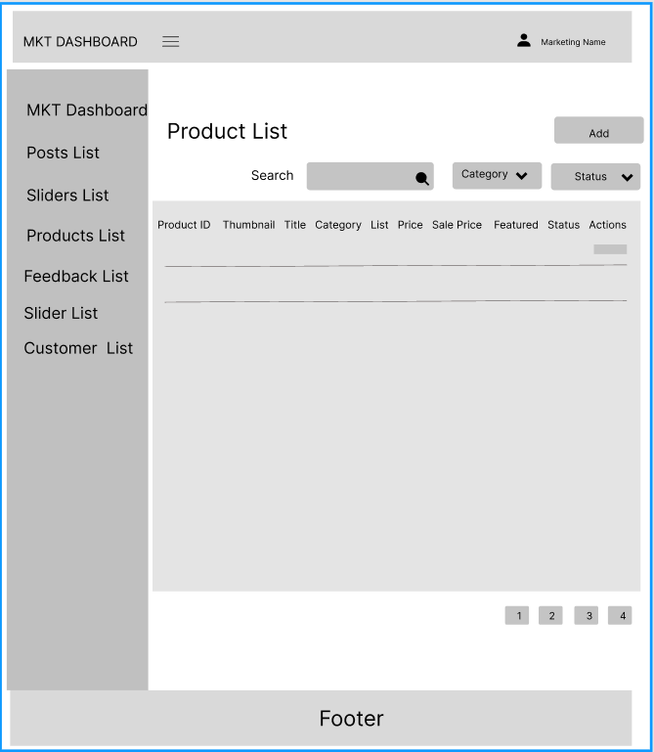

* Function detail:
  + User can search user by name, id, and also filter by status, fetured and category, a list of matching product will be displayed in on the table
  + When user click on “Add” button user will be redirected to Add new product page
  + When user click on “Edit” button user will be redirected to Edit product profile page

### g. Product Details

* Function trigger: After logged website with role admin, user click “Product List” in the sidebar, user user will be redirected to user list page and user click on “Edit” button user will be redirected to product details page
* Function description:
  + Role : Adim
  + Purpose: View or edit product information
* Screen layout:

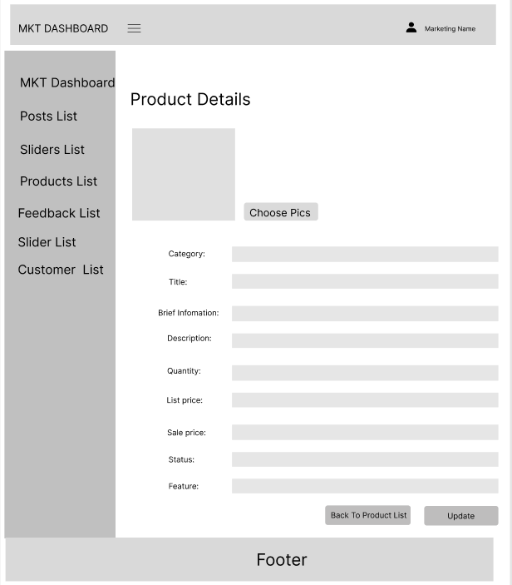

* Function detail:
  + User can edit thumbnail and attached image product
  + User can edit Name of descrption
  + User click on Category drop down a list rocategory will be displayed
  + User can edit price
  + User can edit discount
  + User can chose only one status
  + User can chose only one fetured
  + When user click on “Save” button user will be redirected to Add new user page, user’s information will be update and and admin will redirect to the list user page

### h. Customers List

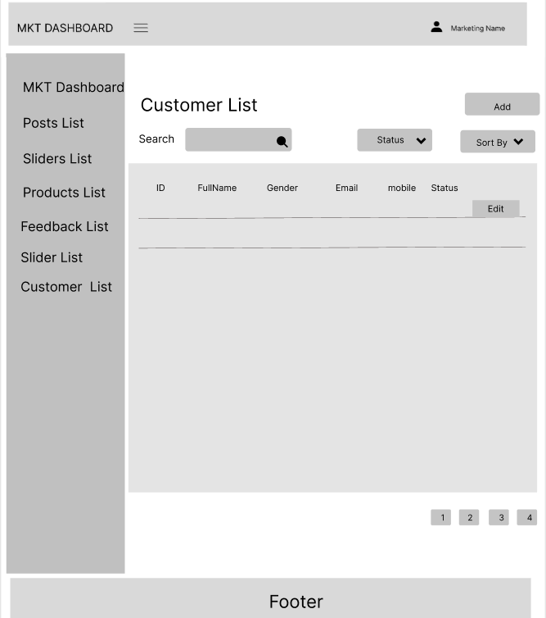

### i. Customers Details

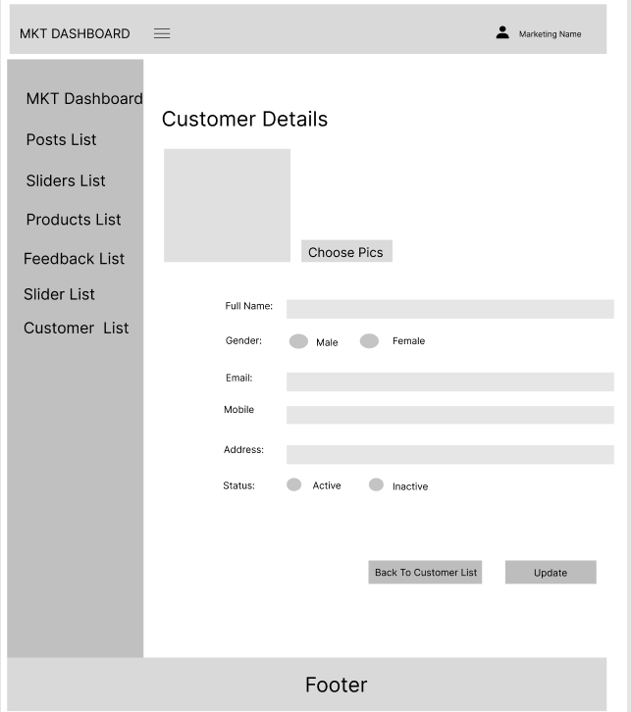

### j. Feedbacks List

* Function trigger: After logged website with role marketing, user click “Feedback List” in the sidebar, user user will be redirected to feedback list page and user can click on a button of collum status to change status of feedback and button “view” user will be redirected to feedback details page
* Function description:
  + Role : Marketing
  + Purpose: View list feedback
  + Screen layout:

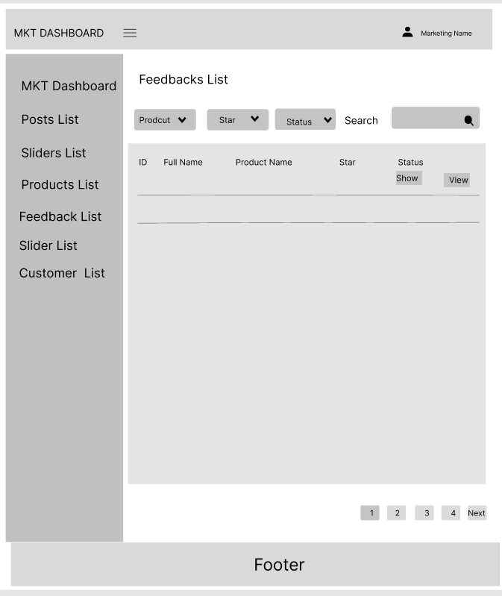

### 

* Function detail:
  + User can view list all feedback
  + User can change status of feedbacks
  + User can view feedback detail though click on “View” button
  + User can chose only one status

### 

### k. Feedback Details

* Function trigger: After logged website with role marketing, user click “Feedback List” in the sidebar, user user will be redirected to feedback list page and user can click on a button of collum status to change status of feedback and button “view” user will be redirected to feedback details page
* Function description:
  + Role : Marketing
  + Purpose: View details of a specific feedback
  + Screen layout:

## 

## Function details: this page allow marketing user to view details of a specific feedback. It’s also allow user to edit the status of the feedback.

## 5. Sale Feature

### a. Sale Dashboard

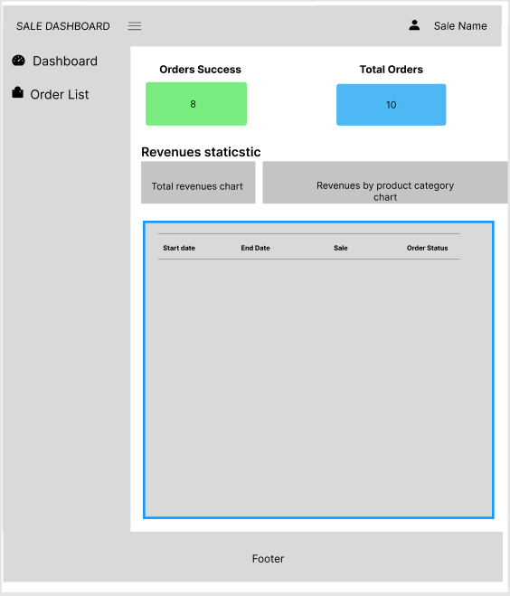

### b. Orders List

* Function trigger: After logged website with sale role, user join sale dashboard and click “Order List” in the sidebar, user user will be redirected to orderlist page
* Function description:
  + Role : Sale manager, sale
  + Purpose: View list user orders.
* Screen layout:

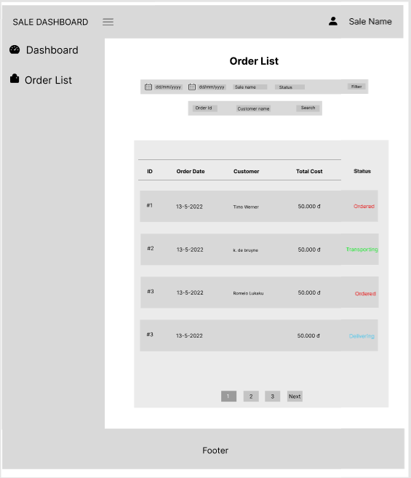

### Function details: When sale user click on “Order list” on the sale dashboard, it will be redirected to “Order list page”. This page view all customer’s orders in the current date by default. The sale user can filter data by date range, by sale or by order status. The sale user can search by order id or by customer name.

### c. Order Details

* Function trigger: After logged website with sale role, user join sale dashboard and click “Order List” in the sidebar, user user will be redirected to orderlist page. And then user click “View” on a order, it will be redirected to order details page.
* Function description:
  + Role : Sale manager, sale
  + Purpose: View details user orders (Such as: Basic order information, receiver information and customer order’s products). The assigned sale and sale manager can change the status of the order or edit order note. Sale manager can assign order to other seller.
* Screen layout:

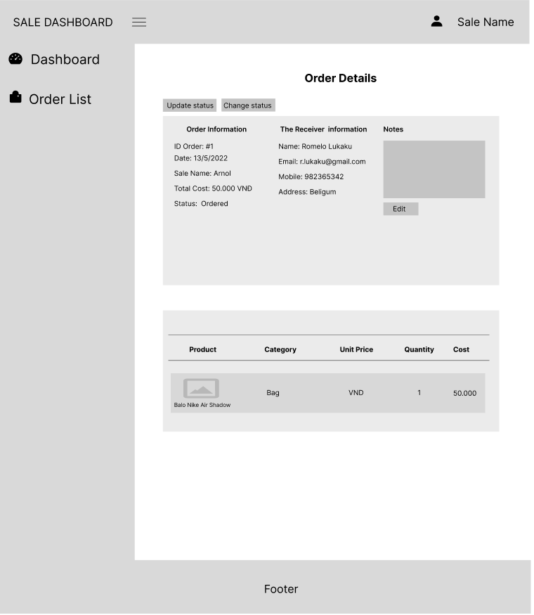

* Function details: This page allow sale user to view the details of an specific customer’s order. It allow assigned sale can update order status and order note. Also, the sale manager can update order status and order note too, but it can assign the order to other sale.

## 

## 

## 

## 

## 6. Adim Feature

### a. Admin Dashboard

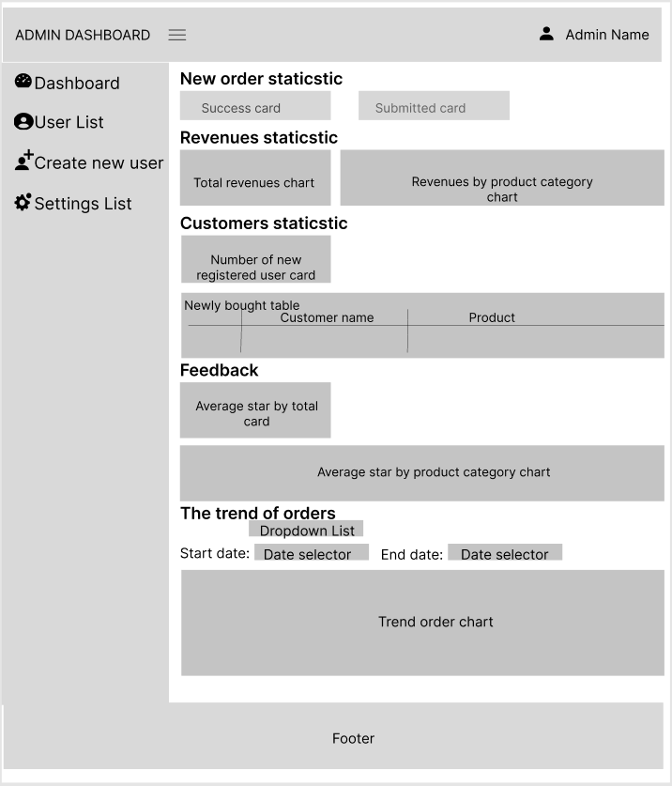

### 

### b. Users List

* Function trigger: After logged website with role admin, user click “User List” in the sidebar, user user will be redirected to user list page
* Function description:
  + Role : Adim
  + Purpose: View list user
* Screen layout:

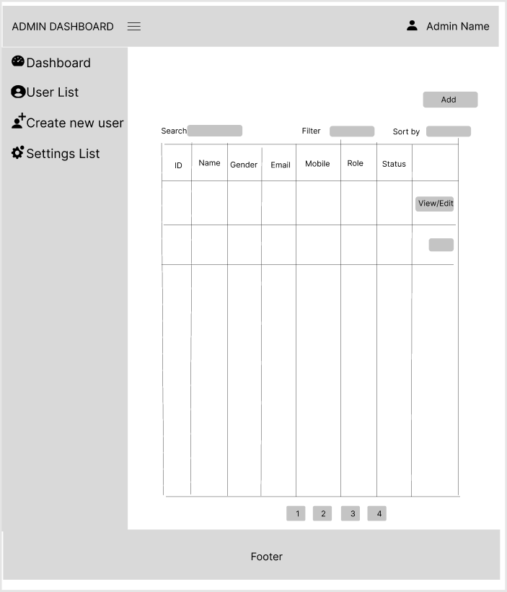

* Function detail:
  + User can search user by name, mobile, email and also filter by status and role, a list of matching users will be displayed in on the table
  + When user click on “Add” button user will be redirected to Add new user page
  + When user click on “Edit” button user will be redirected to Edit user profile page

### c. User Details

* Function trigger: After logged website with role admin, user click “User List” in the sidebar, user user will be redirected to user list page and user click on “Edit” button user will be redirected to user details page
* Function description:
  + Role : Adim
  + Purpose: View or edit user profile
* Screen layout:

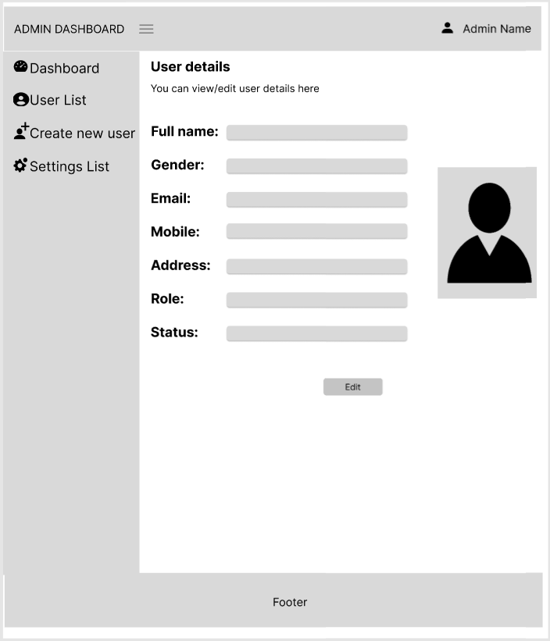

* Function detail:
  + Admin click on Role drop down a list role will be displayed
  + Admin can chose only one status
  + When user click on “Save” button user will be redirected to Add new user page, user’s information will be update and and admin will redirect to the list user page

### 

### 

### 

### d. Settings List

### 

### 

### e. Setting Details

● Function trigger: Setting detail can be access from setting list when user click on “view/update” button

● Function description:

o Role: Admin

o Purpose: User can view all the detail information of a Setting

● Screen layout:

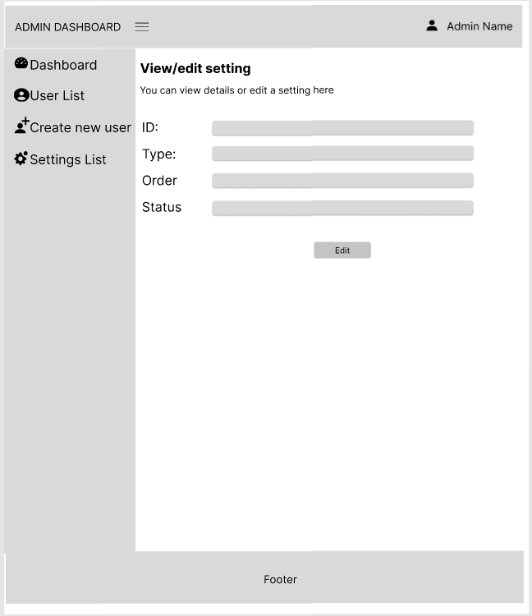

● Functional detail: